

Reviews on research paper on Drone controlling with neurone system.

Name:- Raisa Faruqui

ID:- 1430962643

Course:- 499A

Faculty:- Mohammad Ashrafuzzaman Khan (Azk)

**Paper – 1**

Title:- Quadcopter control in three-dimensional space using a non-invasive motor imagery-based brain–computer interface

Author:- Karl LaFleur, Kaitlin Cassady, Alexander Doud, Kaleb Shades, Eitan Rogin1 and Bin He.

Review:-

In this paper we learnt about an experiment of BCI controlling a robotic quadcopter in three-dimensional (3D) physical space using non-invasive scalp electroencephalogram (EEG) in human subjects. Before getting into details we need to know what is **Non- invasive EEG?** An electroencephalogram (**EEG**) is the recording of the brain electrical activity and it is non- invasive since no surgery is required. They then measured this system using metrics suitable for asynchronous BCI. Brain–computer interfaces are systems that aim to restore or enhance a user’s ability to interact with the environment via a computer and through the use of only thought. We demonstrate for the ﬁrst time the ability to control a ﬂying robot in 3D physical space using non-invasive scalp recorded EEG in humans. In this paper they have overviewed and did physical experiment along with the data. They used AR Drone 1.0 quadcopter (Parrot SA, Paris, France) because it provides strong on-board stabilization while allowing for a wide range of programmable speeds and a smooth range of motion. It is a relatively low-cost option for robust control in 3D space with extensive open source support. In addition, the AR Drone provided access to two onboard cameras, and the accelerometer, altitude, and battery data were all reported to the control software and recorded in real time.

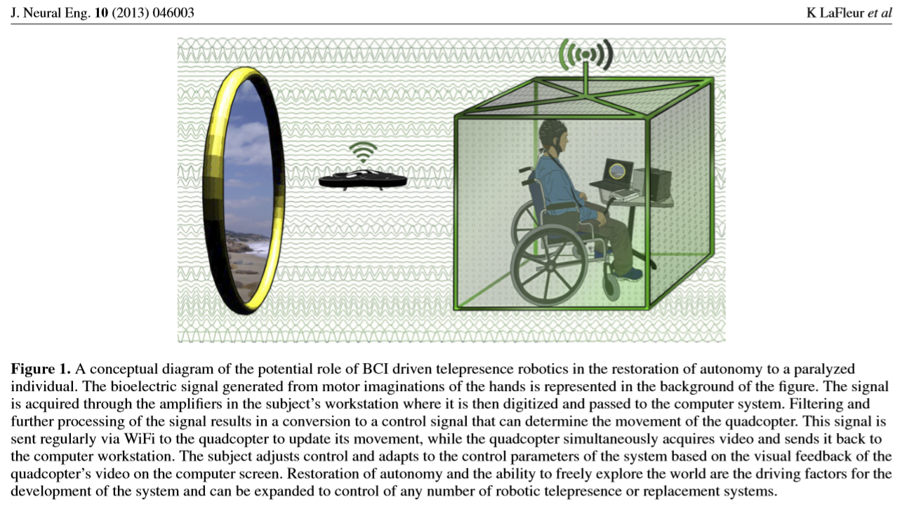

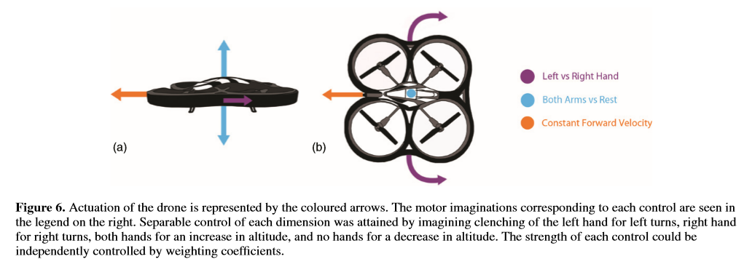

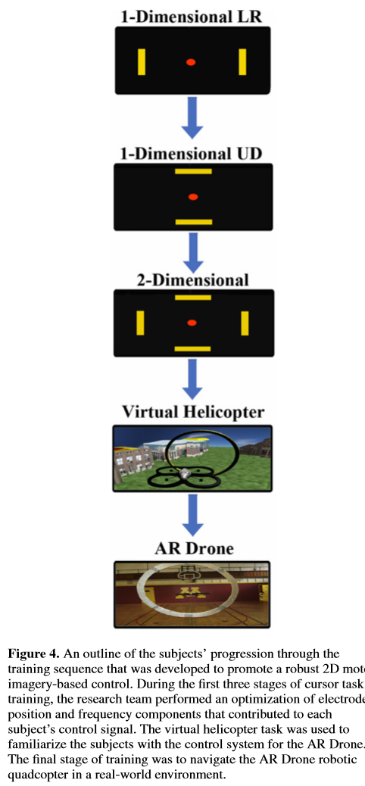

<https://iopscience.iop.org/article/10.1088/1741-2560/10/4/046003/pdf>

**Paper - 2**

Title:- Flying Buddy 2: A Brain-controlled Assistant for the Handicapped

Author:- Yipeng Yu, Dan He, Weidong Hua, Shijian Li, Yu Qi, Yueming Wang, Gang Pan.

Review:-

In this paper they uses the brain EEG signals to directly control a quadrotor. Signals from an EEG headset are transmitted wirelessly to a computer, then the decoded brain signals are converted to trigger the quadrotor to move in 3D space. Three applications are developed: thinking to play games, thinking to see, and thinking to take pictures. They composed in 3 components, i.e. - : signal processing, control strategy, and AR.Drone control application. It has an ultrasound telemeter for altitude measures, two cameras separately mounted in the bottom and front, and many other motion sensors. AR.Drone control application module gets commands from control strategy module, and sends it to the AR.Drone through Wi-Fi. Also it constantly receives the video streams and motion parameters from the sensors. Signals processing module evaluates real time brainwave activity to discern the intents of the user. The amplitude of filtered brain signals is used as feature that reflects ERD/ERS, by means of quantification of different temporal-spatial patterns, we could detect three motor imagery brain activities: think left, think right, and think push. Eye blinking and tooth clenching can introduce artifacts to EEG signals, which can also be detected and converted to specific control commands

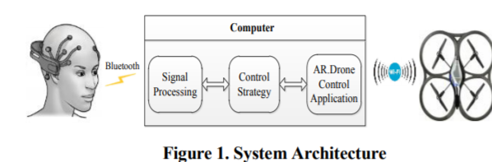

<http://citeseerx.ist.psu.edu/viewdoc/download?doi=10.1.1.592.3159&rep=rep1&type=pdf>